1. Creating and Renaming Files/Directories
Create a directory named test_dir using mkdir.
Inside test_dir, create an empty file called example.txt.
Rename example.txt to renamed_example.txt using mv

Mkdir command is used to create new directories .
Solution:
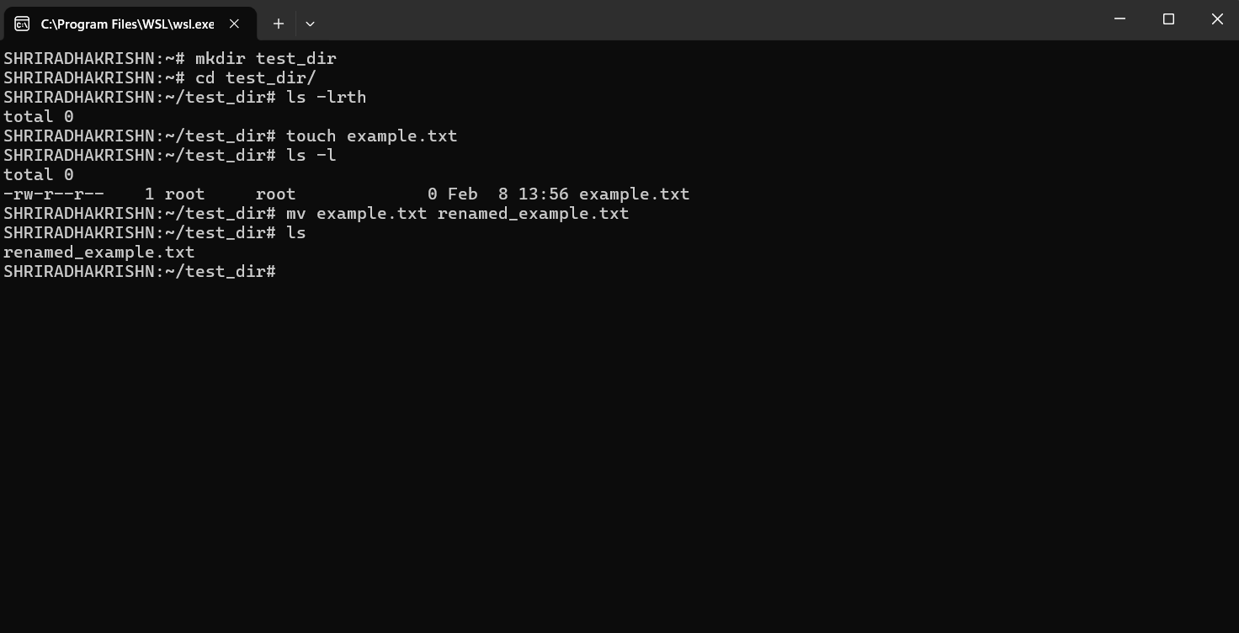

2. Viewing File Contents
Use cat to display the contents of /etc/passwd.
Display only the first 5 lines of /etc/passwd using head.
Display only the last 5 lines of /etc/passwd using tail.
Cat is used to display the file contents.
Head is used to display the top lines of the file we can use -n as well and a give a number so it will give that many lines from top.
Tail is used to display the bottom lines of the file we can use -n as well and a give a number so it will give that many lines from bottom.

Solution:

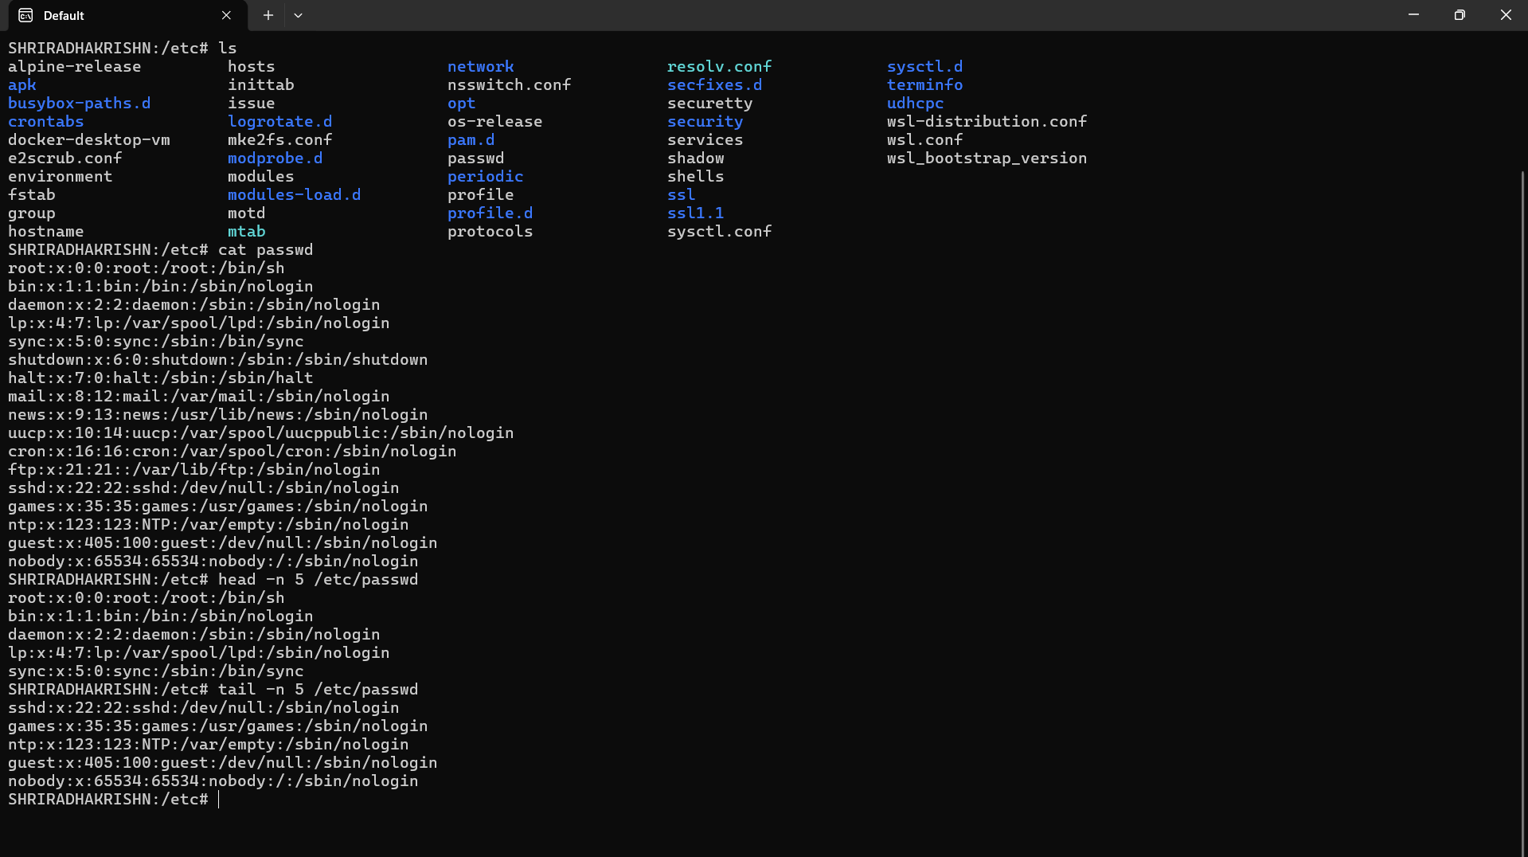
3.Searching for Patterns
Use grep to find all lines containing the word "root" in /etc/passwd.

Grep is used to find the patterns in the below case it has been used to find the line in which the pattern is present.
Solution:
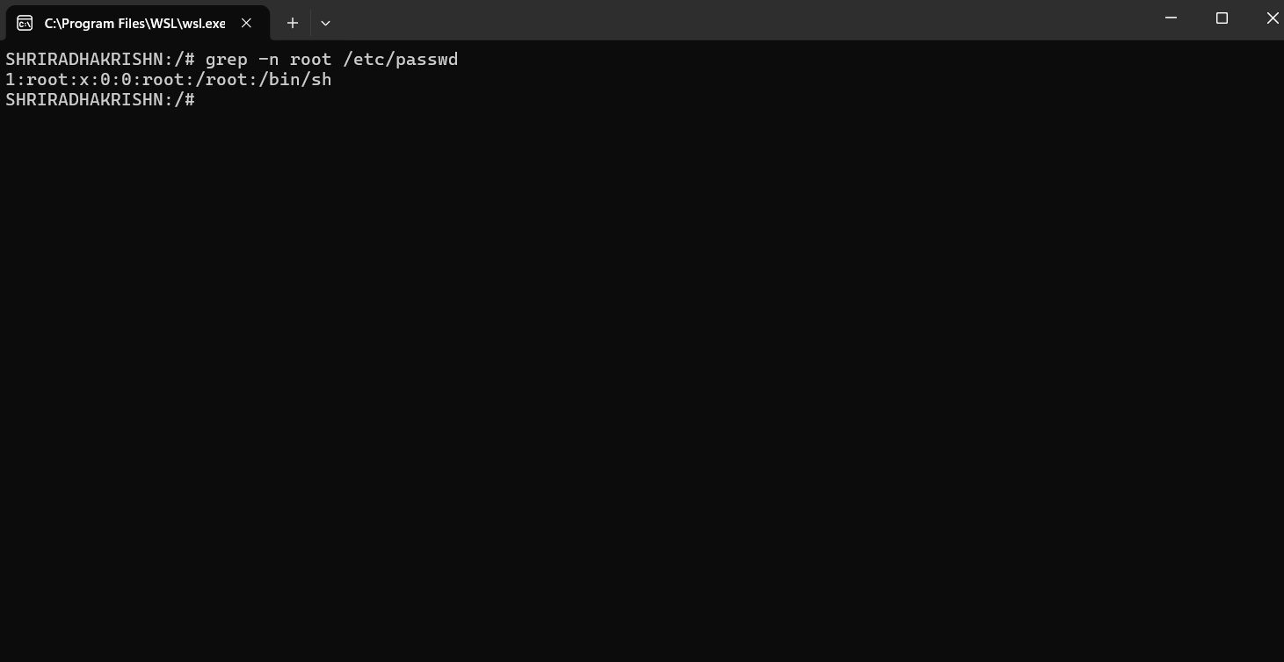

4. Zipping and Unzipping
Compress the test_dir directory into a file named test_dir.zip using zip.
Unzip test_dir.zip into a new directory named unzipped_dir.

This command compresses the test_dir folder into test_dir.zip, then extracts it into a new folder called unzipped_dir.
Solution:
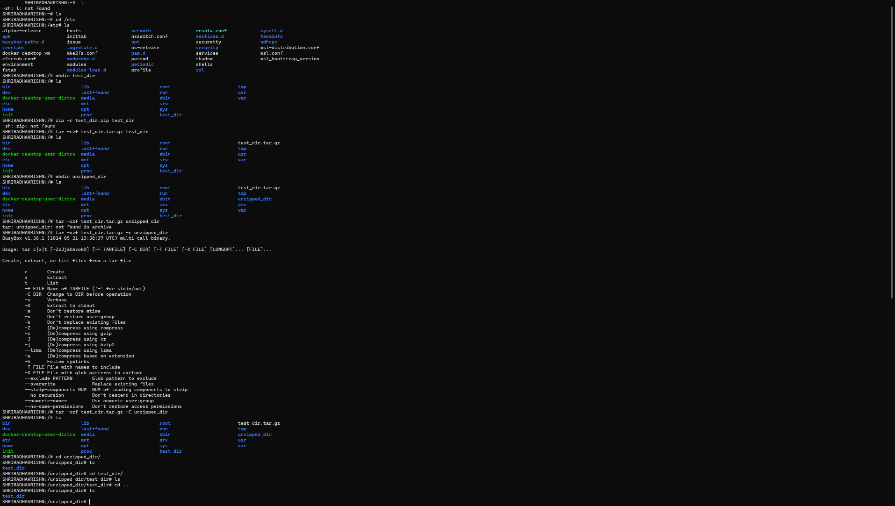

5. Downloading Files
Use wget to download a file from a URL (e.g., https://example.com/sample.txt).

Wget command is used to download a file from the URL which ha been mentioned.
Solution:
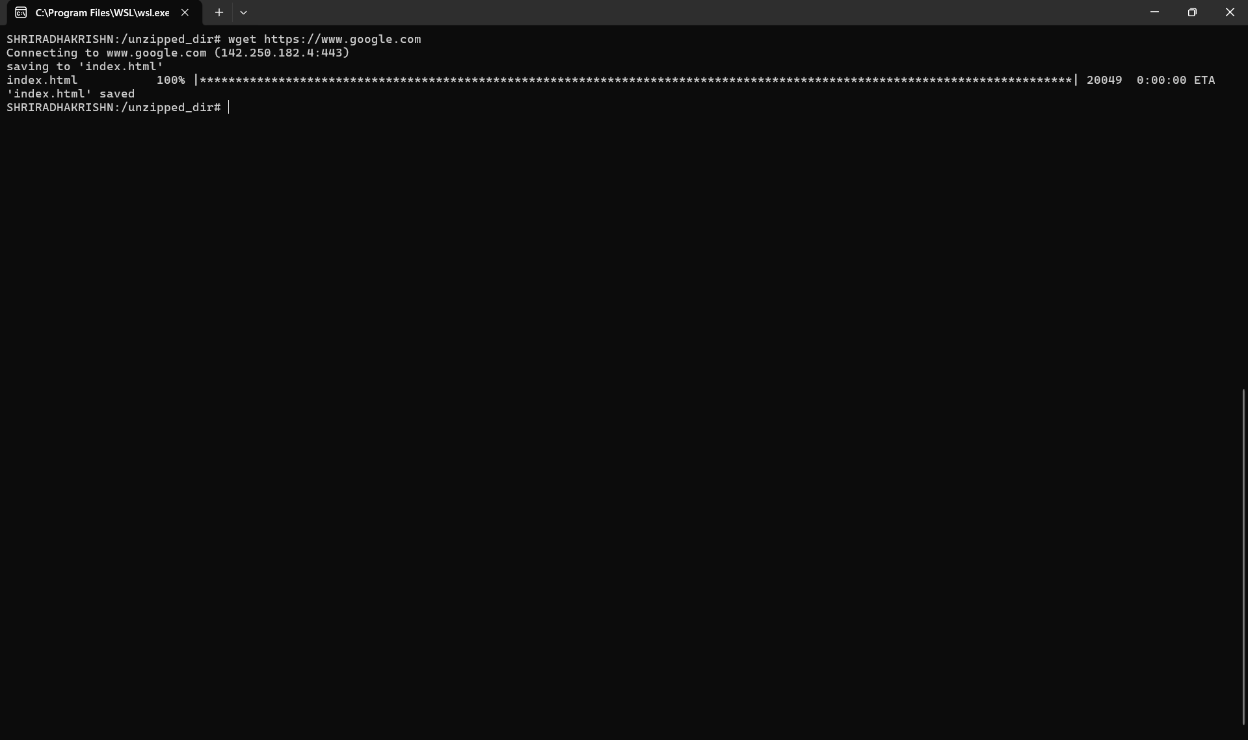

6. Changing Permissions
Create a file named secure.txt and change its permissions to read-only for everyone using chmod.

This command is used to change the permission of the file .
Solution:
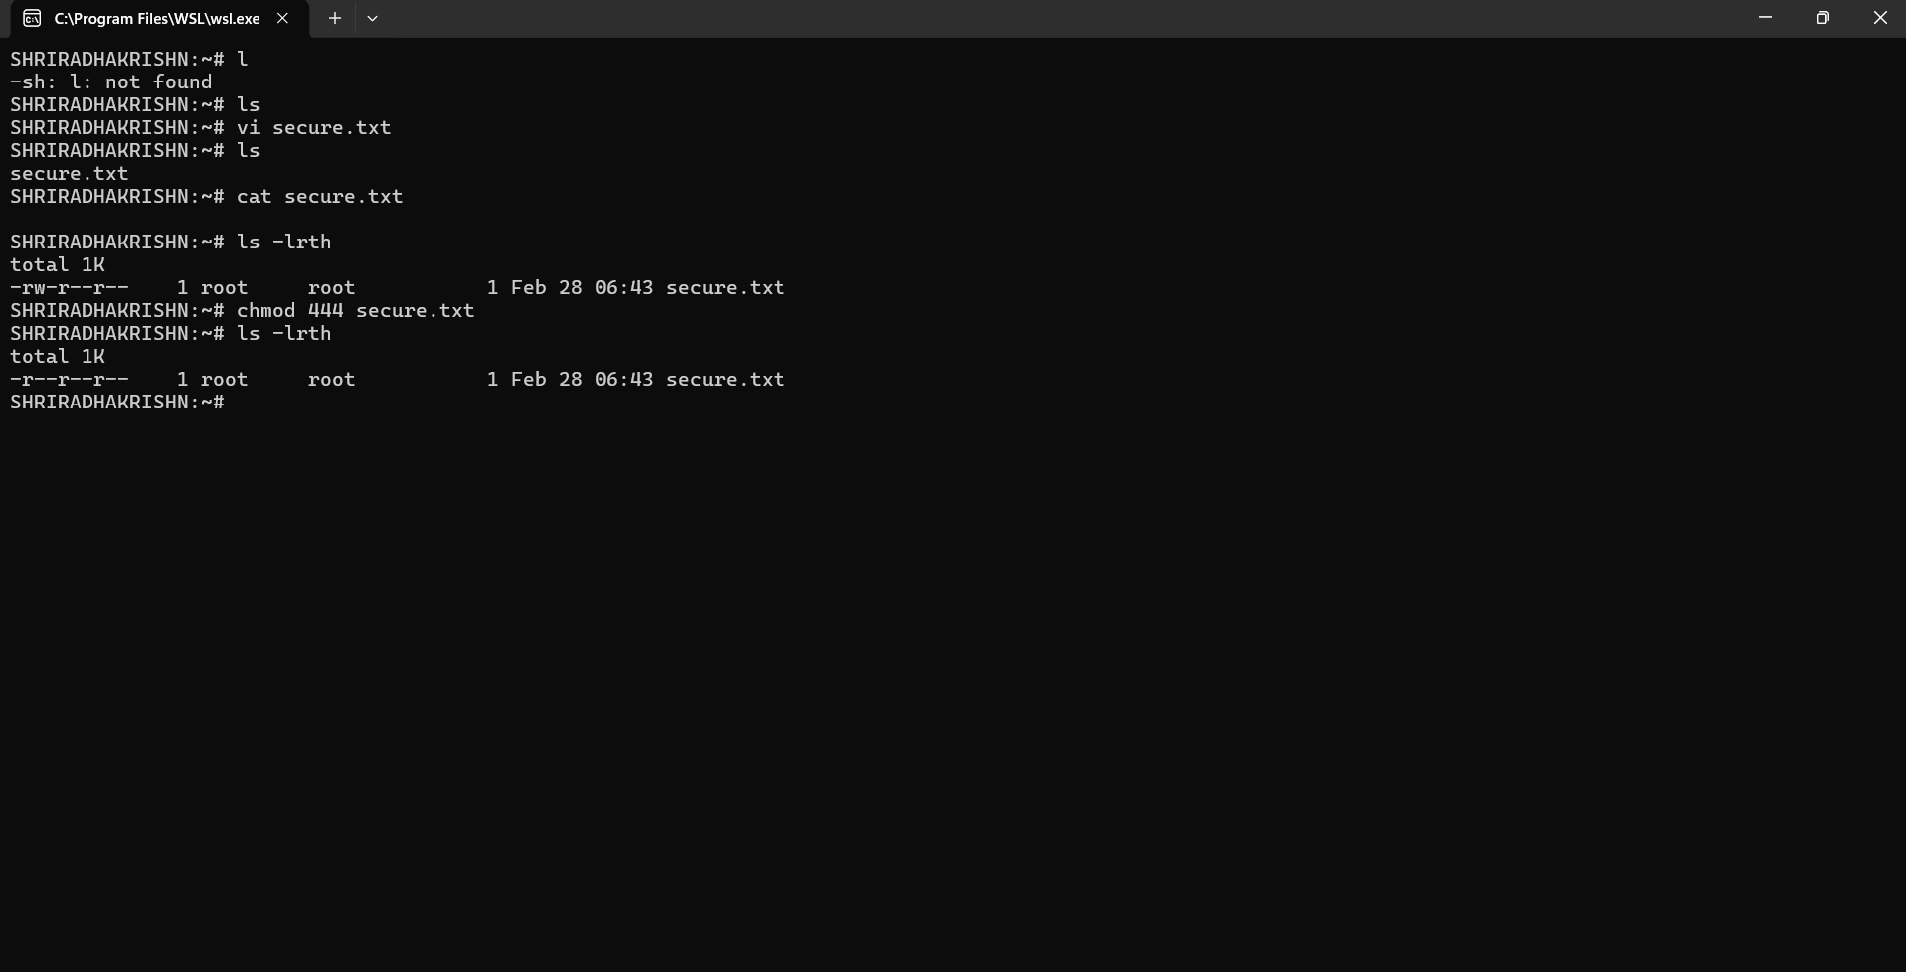

7. Working with Environment Variables
Use export to set a new environment variable called MY_VAR with the value "Hello, Linux!".

This command is used to set the env variables

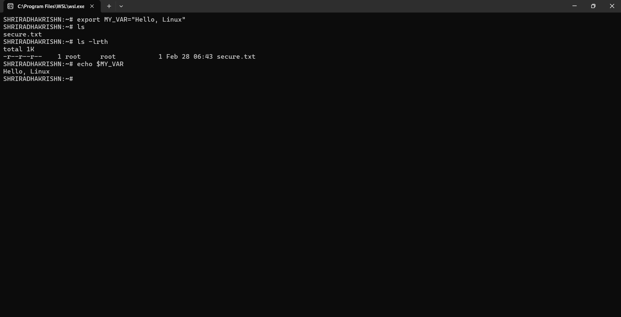

Submission Guidelines -: Attach Screenshots or command along with explanation and submit in doc(google doc or microsoft doc) format also attach github repo link

